|  |  |
| --- | --- |
| USAID Logo | USAID GLOBAL HEALTH SUPPLY CHAIN PROGRAM  Procurement and Supply Management |

|  |
| --- |
| Facility Inventory Turnover Analysis Learning Guide  **Incorporating Inventory Turnover Analysis into Last-Mile Stock Management to Enable Targeted Actions for Family Planning and other Commodities**  November 13, 2024 |

The USAID Global Health Supply Chain Program-Procurement and Supply Management (GHSC-PSM) project is funded under USAID Contract No. AID-OAA-I-15-0004.GHSC-PSM connects technical solutions and proven commercial processes to promote efficient and cost-effective health supply chains worldwide. Our goal is to ensure uninterrupted supplies of health commodities to save lives and create a healthier future for all. The project purchases and delivers health commodities, offers comprehensive technical assistance to strengthen national supply chain systems, and provides global supply chain leadership.

GHSC-PSM is implemented by Chemonics International, in collaboration with Arbola Inc., Axios International Inc., IDA Foundation, IBM, IntraHealth International, Kuehne + Nagel Inc., McKinsey & Company, Panagora Group, Population Services International, SGS Nederland B.V., and University Research Co., LLC. To learn more, visit [ghsupplychain.org](http://www.ghsupplychain.org/)

DISCLAIMER:  
The views expressed in this publication do not necessarily reflect the views of the U.S. Agency for International Development or the U.S. government.

Contents

Contents 1

Acknowledgments 2

Acronyms 3

1. Introduction 4

2. What is an Inventory Turnover Ratio? 5

2.1 Why Do Inventory Turnovers Matter? 5

2.2 How is an Inventory Turnover Ratio Calculated? 6

2.3 What is an Ideal Inventory Turnover Ratio? 6

2.4 How Does Inventory Turnover Fit into a Maximum-Minimum Inventory Control System? 7

2.5 Current State of Stock Monitoring at Last-Mile Facilities 9

2.6 How Does Inventory Turnover Ratio Differ from More Commonly Tracked Metrics? 11

3. The Facility Inventory Turnover Analysis (FITA) Dashboard 13

3.1 Country Example Use Case: How to Apply Inventory Turnover Ratios for Insights 15

4. Next Steps 20

Acknowledgments

This learning guide and associated interactive tool were supported by the USAID Office of Population and Reproductive Health. The authors would like to thank Kevin Gandhi and Kevin Pilz for their guidance and support. They would also like to thank Daniel Taddesse and the Malawi field office for offering their eLMIS data and feedback and guidance for the development of this tool and learning guide; the data has been anonymized in the use cases in this report. The draft was a collaborative effort between several GHSC-PSM Health Systems Strengthening (HSS) teams who drafted or reviewed the guidance, including HSS Warehousing and Distribution & Supply Chain Innovations (Jaya Chimnani, Steven Thomas), HSS Technical Director (Barry Chovitz), HSS Advanced Analytics (Eileen Patten, Japnit Kaur), and HSS Director Ralph Titus. Special thanks also to Andrew Inglis, former HSS Advanced Analytics team lead, and the country directors who participated in the survey. We thank all contributors and reviewers for their input.

**Acronyms**

|  |  |
| --- | --- |
| AMC | Average Monthly Consumption |
| CEO | Chief Executive Officer |
| eLMIS | Electronic Logistics Management Information System |
| FITA | Facility Inventory Turnover Analysis |
| GHSC-PSM | Global Health Supply Chain Program-Procurement and Supply Management |
| GUI | Graphical User Interface |
| KPI | Key Performance Indicator |
| LMIS | Logistics Management Information System |
| MOS | Months Of Stock |
| SOH | Stock On Hand |
| UTR | Unit Turnover Ratio |

1. Introduction

In the digital age of managing supply chains, it is crucial to recognize opportunities where public health supply chains can evolve beyond traditional key performance indicators (KPIs) and metrics. The adoption of digital technologies and data systems has removed the barrier of manual calculations, enabling the rapid calculation of additional KPIs across thousands of facilities. This has created a window of opportunity for public health supply chains to harness the power of enhanced digital supply chain data, leveraging new KPIs to drive more-informed decision-making and providing valuable insights across the supply chain, including at the last mile.

***This learning guide will explain how one such key metric, inventory turnover ratios, can be used alongside more historically tracked last-mile metrics, such as months of stock (MOS) and stockout rates, to make data-driven decisions and take targeted actions at the facility level.***

It should be noted that this guide and its featured tool focus on using electronic logistics management information system (eLMIS) facility-level data to measure inventory turnover ratio and other last-mile KPIs; inventory turnover ratio are more commonly measured in warehouses or distribution centers using a warehouse management system to track issuances and stock levels. For example, the manual “Winning the Logistics Game” covers the importance of inventory turnover for warehouses and distribution centers.[1] The Quantification Analytics Tool (QAT) is another analytics tool developed by the USAID Global Health Supply Chain Program-Procurement and Supply Management project (GHSC-PSM) for country-led forecasting and supply planning and includes measures of inventory turnover ratio at the central warehouse level.[2]

There are some examples of countries that have already been using inventory turnover ratios to manage last-mile stock management. For example, Pakistan has been tracking this metric since at least 2013, according to a report by the USAID DELIVER project.[3] However, the quality and availability of many countries’ eLMIS data has improved over the past ten years, making it possible for more countries to automate the calculation of this data across thousands of facility-product combinations. But adoption of new metrics may not always keep pace with data improvements and digitization. In our survey of seven countries, only three were using inventory turnover ratios as a measure of the health of the supply chain at the last mile.

This learning guide will:

1. Introduce and define inventory turnover ratios (for public health supply chains).
2. Provide an overview for calculating and interpreting inventory turnover ratios.
3. Introduce an analytics tool, Facility Inventory Turnover Analysis (FITA) dashboard, as an option for calculating and visualizing inventory turnover ratios.
4. Provide examples of how to leverage the insights from applying inventory turnover ratios
5. Serve as an advocacy document for anyone interested in promoting the use of last-mile inventory turnover ratios alongside other KPI metrics for tracking last-mile stock management.

Examples of audiences that might benefit from this document include, but are not limited to, ministries of health, supply chain managers, and countries interested in better understanding how to manage inventory at the last mile to mitigate under- or over-stocking and expiries.

Accompanying this learning guide is an Excel-based dashboard with instructions for how a country can set up their dashboard to utilize their country specific digital supply chain data, along with instructions for integrating inventory turnover ratios with the country’s existing last-mile tools or dashboards.

1. What is an Inventory Turnover Ratio?

**Inventory turnover ratio measures the number of times a facility dispenses and replaces its inventory during a period under review and is a measure of efficiency of the operation.**

In other words, the time from when product is received at a facility until the time the last unit of the product at the facility is dispensed to a patient represents one turn of inventory. Inventory turnover is measured by dividing the units dispensed over a period (i.e., total consumption) by the average stock on hand during that period. The inventory turnover ratio is therefore measured as the number of times the inventory turns over per period. For example, if a facility dispenses 100 units per year and keeps 20 units in stock on average across the months or days in that same period, then it would average five inventory turnovers per year.

2.1 Why Do Inventory Turnovers Matter?

Inventory turnover ratio is commonly used in the private sector to understand the average time a company takes to sell its inventory. This helps them make better decisions on pricing, manufacturing, marketing and purchasing. In the private sector, a warehouse’s customers (e.g., stores, pharmacies) may also track their own inventory turnover ratio to ensure efficient stock management. However, the public health domain in low- and middle-income countries is unique in that the country’s ministry of health or logistics operators often monitor the stock holding behavior of their customers to ensure efficient use of limited resources.

In public health supply chains, many of the commodities are donated. However, the inventory turnover ratio can still be a powerful metric to gauge the flow of inventory moving in and out of facilities and determine how efficiently a supply chain is functioning, as well as what risks a facility may face in their stock management. The inventory turnover ratio can be measured at any level of the supply chain, from national warehouses to regional hubs to last-mile facilities, with the caveat that the quality and the granularity of the data may vary greatly at each level of the supply chain.

This report focuses not only on how to calculate inventory turnover ratio but, more importantly, on how to use this metric to measure the stock management performance at last-mile facilities to review and, when needed, act. For example, this report highlights how both low and high inventory turnover can be detrimental to a public health supply chain. Persistently low inventory turnover at a health facility can clog up storage space that may be needed for more in-demand drugs, lead to higher storage cost, increase the potential of spoilage, expiry, or loss, increase the level of effort for stock management and reporting tasks, and can make demand forecasting more challenging. Even though health commodities are often donated, inventory insurance costs could be saved by increasing inventory turnovers and reducing stock on hand for facilities. By contrast, inventory turnover that is too high is also a concern, as it can indicate an increased risk for stockouts, shortages, and emergency orders; and it makes any delays in scheduled deliveries a risk for stock availability.

Monitoring inventory turnover on a regular basis can help sites function more efficiently as they can quickly identify and take targeted actions to keep the flow of inventory well-maintained, resulting in being able to:

* Measure and assess the strength and health of the supply chain on a routine basis.
* Quickly adapt to changing consumption trends.
* Reduce storage costs by maintaining inventory within the established parameters.
* Reduce wastage, expiry, and loss.
* Avoid future stockouts and shortages that result in emergency orders.

2.2 How is an Inventory Turnover Ratio Calculated?

The most common method of calculating inventory turnover ratio focuses on the value or cost of goods, especially when inventory turnover ratio is measured in the commercial sector. For example, the USAID GHSC-PSM National Supply Chain Assessment (NCSA) Toolkit defines the inventory turnover ratio in a warehouse (which they refer to as “stock turn per annum”) as:

*((Total value issued) / (Average value of inventory held in the period)) = X (number of turns)*

Since the value of donated goods may not always be known at the facility level, facilities may rely on a variation of inventory turnover ratio sometimes called the “unit turnover ratio” (UTR), where the value issued and value of inventory is replaced by number of units.[4] For example,

*((Total consumption in units) / (Average units of inventory held in the period)) = X (number of turns)*

In One Year, if:

Total Consumption = 1,000 and Average Stock on Hand = 100, then

$$\frac{1000}{100}=10 Turns$$

The inventory turnover ratio, therefore, is measured as the number of times per year inventory turns over or moves through a facility. Inventory turnover ratio can also be seen as an inverse of months of stock (MOS); if 12 months is divided by the inventory turnover ratio, the result is the number of months it will take inventory to turn. This number is also the average monthly stock stored. For example, if inventory turns over 10 times per year, it means that inventory turns over every 1.2 months and thus the facility holds on average about 1.2 months of stock on hand.

It is important to note that inventory turnover ratio does not always need to be measured on an annual basis, though this is typical, particularly in cases where there is not substantial seasonal variation. However, when considering products for treatments such as malaria, which often have a high- and low- transmission season based on weather patterns, it may be better to measure inventory turnover ratio for a shorter segment of time, such as each high- or low- transmission season, as variable consumption may lead to variable inventory turnover if stock management is not adjusting well. In these cases, an annual average may hide season-specific variation. If the high-transmission malaria season is six months in length, changing the window to six months will enable inventory turnover ratio calculations to be generated separately for the high- and low-transmission months and capture the changing trend in consumption.

2.3 What is an Ideal Inventory Turnover Ratio?

The ideal inventory turnover ratio varies greatly by product, industry, and other factors. That said, a general guideline in public health supply chains where inventory control policies drive scheduled ordering cycles (e.g., monthly, bimonthly) is that the turnover ratio should align roughly with the frequency of delivery to maximize inventory turnover while not stocking out. If the frequency of delivery is monthly, then what is the expected turnover? The answer is around 12 turns a year, or possibly a little under that number to account for safety stock held. Anything more than that would indicate a **fast-moving** product and may require adjustment to the delivery quantity to avoid future stockouts. A site turning inventory less often indicates a **slow-moving** product which leads to an issue of over-stocking, potentially resulting in expiry and wastage.

That said, there is a difference between what is expected or ideal based on current inventory control policies, and what is ideal to improve stock management and efficiency overall.

A country that increases delivery frequency and thus allows faster inventory turnover at the last mile will see better outcomes in stock availability, reduced losses, and reduced inventory storage costs. Therefore, when possible, countries should strive for more frequent deliveries to drive higher inventory turnovers, especially to the largest facilities.

2.4 How Does Inventory Turnover Fit into a Maximum-Minimum Inventory Control System?

Public health supply chains in low- and middle-income countries often use a forced ordering maximum-minimum inventory control system. In this type of system, each facility is required to order up to their maximum inventory level at the end of each review period. With this approach, facilities are expected to maintain large amounts of safety stock, with typical guidance advising at least half the review period’s worth of inventory. For countries with bi-monthly deliveries, this could mean holding an entire month’s worth of stock just in safety stock.

|  |  |  |  |  |  |
| --- | --- | --- | --- | --- | --- |
| **Exhibit 1. Hypothetical Facility Inventory Flows to Demonstrate how Planned Inventory Turnover is Driven by Max-Min Inventory Control Policies** | | | | | |
| Max: 3 MOS (2,000 units)  Frequency of delivery: Bi-monthly | | | | | |
|  | 1st Day | Consumption | Shipment | Last Day |
| Jan | 2,000 | 667 | - | 1,333 |
| Feb | 1,333 | 667 | 1,334 | 2,000 |
| Mar | 2,000 | 667 | - | 1,333 |
| Apr | 1,333 | 667 | 1,334 | 2,000 |
| May | 2,000 | 667 | - | 1,333 |
| Jun | 1,333 | 667 | 1,334 | 2,000 |
| Jul | 2,000 | 667 | - | 1,333 |
| Aug | 1,333 | 667 | 1,334 | 2,000 |
| Sep | 2,000 | 667 | - | 1,333 |
| Oct | 1,333 | 667 | 1,334 | 2,000 |
| Nov | 2,000 | 667 | - | 1,333 |
| Dec | 1,333 | 667 | 1,334 | 2,000 |
|  |  |  |  |  |
|  | | Average SOH | Annual Consumption | Planned  Inventory Turnover |
| 1,666 | 8,000 | 4.8 |
|  | | Planned Inventory Turnover Range  (+/- 1.5) |
| 3.3 - 6.3 |

For example, as shown in the table to the right, the policy for the hypothetical country requires 3 MOS even though a delivery will arrive every 2 months. This results in 1 MOS (667 units) of safety stock left over every time a new delivery is received every 2 months.

The “planned” inventory turnover under this type of system ***—*** or what level would be expected given the inventory control policies ***—*** can be calculated based on the max-min MOS levels and the delivery frequency policies. For example, for a product category with maximum MOS as 3 and with bimonthly deliveries, expected inventory turnover would be around 4.8 times per year, as shown in the example in the table to the right. This was calculated as follows:

* If we assume 3 MOS is 2,000 units, then annual consumption would be 8,000 units (i.e., 3 MOS * 4 = 12 MOS).
* Based on bi-monthly deliveries, stock would be replenished every other month back up to 2,000 unit maximum.
* This means the average stock on hand (SOH) using the first and last day of each month to compute an annual average would be around 1,666 units.
* Thus, the inventory turnover ratio would be calculated as 8,000 / 1,666 = 4.8 times per year.

This example shows an ideal and probably non-realistic circumstance, where consumption is perfectly even and shipments always arrive precisely on time, but it is used to demonstrate how the inventory control policy works in theory to drive the maximum inventory turnover.

Since the real world is not as clean as the example above, a range may be more practical than a precise figure for identifying an appropriate inventory turnover ratio. One might consider a range +/- 1.5 months from the calculated expected inventory turnover ratio (e.g., 3.3-6.3 months in the case of 4.8 from above). An inventory turnover ratio less than 3.3 can either mean consumption has reduced and there is a need to adjust order quantities, or the site is receiving sporadic or large quantity orders. On the other hand, an inventory turnover ratio greater than 6.3 can mean that the demand has increased and requires an adjustment to order quantity, or there is an insufficient or irregular supply of commodity. This is explained in examples below:

A text graphic with 3 columns indicating how different average stock on hand leads to different IT even when delivery frequency and total consumption remains constant. Column one says Case 1: Delivery Frequency = 6 times a year, Total Consumption = 8,000 units, Average stock on hand = 4,000 units, What is Inventory
Turnover? 8000 divided by 4000 = 2 Turns, Slower than planned, Inventory Turn Category : Low
Column 2 says: Case 2: Delivery Frequency = 6 times a year, Total Consumption = 8,000 units, Average stock on hand = 2,000 units, What is Inventory
Turnover? 8000 divided by 2000 = 4 Turns, As planned, Inventory Turn Category: Planned. Column 3 says: Case 3: Delivery Frequency
= 6 times a year, Total Consumption = 8,000 units, Average stock on hand = 800 units, What is Inventory
Turnover? 12000 divided by 800 = 10 Turns, Faster than planned, Inventory Turn Category : High

* In Case 1, the inventory turnover is low because they are holding a lot of stock (4,000 units in an average month) relative to their annual consumption (8,000 units or about 667 per month).
* Case 2 shows an instance of planned inventory turnover: they have around 2,000 units of stock on hand on average and the same 8,000 units consumed per year, so their inventory turns over 4 times per year. This value falls in the planned 3.3-6.3 inventory turnover range calculated above, although on the lower end which suggests possible improvements could be made to align more closely with delivery schedules (e.g., 4 turns compared to 6 deliveries per year).
* In Case 3, they are holding 800 units on average and consuming the same 8,000 per year (or 667 per month), meaning that they have 10 turns. In this case, inventory is turning too quickly and leading to stockouts, as they only have 6 deliveries per year. If they were to receive monthly deliveries and maintain stock levels around 800 units, this level of stock holding would be in line with planned inventory turnover.

This demonstration shows how the faster inventory turns over, the less stock on hand is required. However, this can only be accomplished if the delivery frequency is aligned so that the facility does not stock out.

2.5 Current State of Stock Monitoring at Last-Mile Facilities

To understand how last-mile stock is managed today, a survey was conducted to gather insights on the use of supply chain data at the last mile from a global perspective. The survey aimed to understand the current state of stock monitoring at last-mile facilities, to identify common metrics and KPIs used, and to investigate if any country was already using inventory turnover ratios as a key metric. It is important to note that this is not a formal survey with a representative sample and scientific design but was intended to give a rough sense of how GHSC-PSM supported countries are using inventory turnover ratios and, if not, whether they are collecting the data necessary to start. The responses received from the participating countries have been analyzed and compiled below into four key insights.[5]

1. **Many countries still rely on paper logistics management information system (LMIS) data in some or all cases, making data analysis more challenging**.

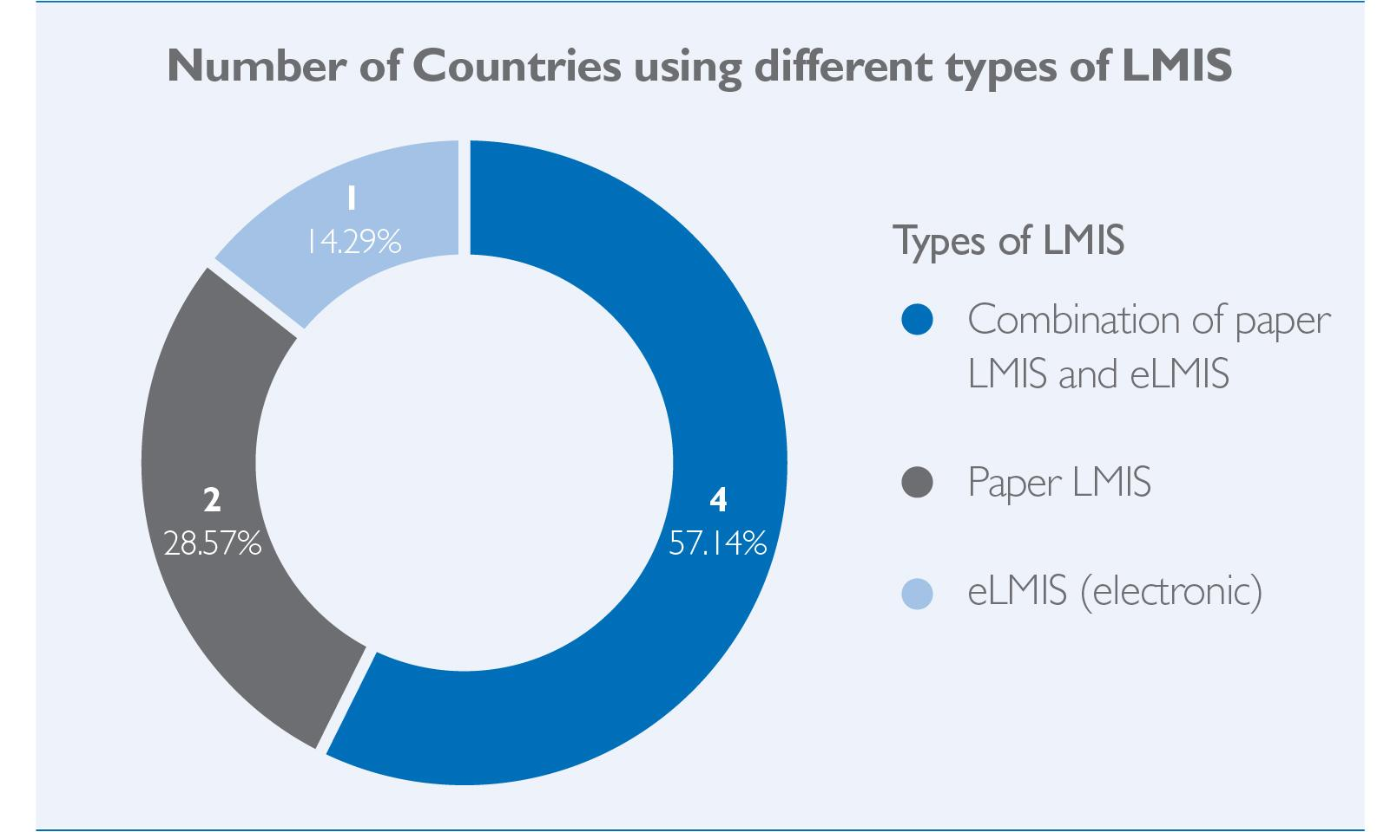Whether LMIS data is captured on paper or in an electronic system can be important in understanding the accessibility of data to produce metrics, such as inventory turnover. Paper-based data collection methods are slower and require manual data entry of a large number of facilities, making last-mile stock monitoring more challenging and less efficient. The survey indicates that some GHSC-PSM countries still rely on paper LMIS, and therefore may struggle to generate timely last-mile stock monitoring KPIs.

1. **A variety of digital tools or software is used to analyze LMIS data, but some countries have no such tool; each of these countries may use the analytics dashboard accompanying this report in a different manner.**

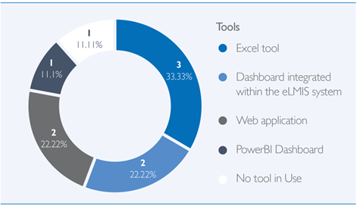Once data is collected, the raw data must be processed into KPI measurements in a format that can be accessed by decision makers (e.g., reports, dashboards). Digital tools are preferred over products like quarterly reports because they can process data in real time as it is captured, and they do not need to be manually prepared for sharing with decision makers. Countries are using a variety of methods to prepare data today, ranging from Excel tools to dashboards integrated within their eLMIS. It would be better to integrate inventory turnover analysis into these tools than to establish a new stand-alone dashboard; the interactive tool accompanying this learning guide can serve as a template in these cases. Only one country said they did not have enough data to establish any type of monitoring tool.

1. **None of the countries surveyed have LMIS data available for all of their facilities, but even monitoring stock management at just a few of the largest facilities can provide valuable insights.**

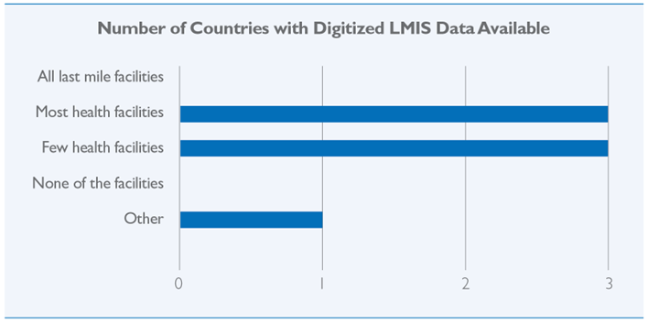Some countries may only capture LMIS data digitally, rather than on paper, for a subset of facilities based on facility type, size, or accessibility of the facilities, for example. In the survey, no countries reported that they have digitized data for all last-mile facilities, but also none of the countries said they had no digitized data available. It is not necessary to have complete data to begin monitoring inventory turnover or other last-mile stock management KPIs; according to Pareto’s Law, 20% of facilities likely account for 80% of the orders in a supply chain, so even just monitoring the largest, most accessible facilities can provide valuable insights.

1. **About half of the countries surveyed were already using inventory turnovers as a metric for last-mile stock management, meaning there is still an opportunity for —** **and interest in —greater adoption of this metric.**

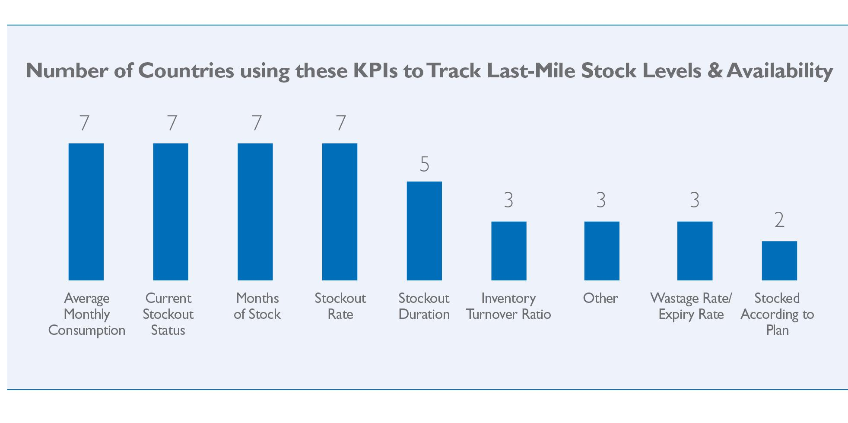Inventory turnover ratio is not a commonly used measure of last-mile stock management currently, especially compared with average monthly consumption (AMC), current stockout status, MOS, stockout rate, and stockout duration. However, about half of GHSC-PSM countries surveyed are using inventory turnover ratio to monitor their last-mile facilities today. Encouragingly, when asked about their interest in incorporating inventory turnover ratio as a metric to monitor last-mile data, each of the seven countries responded as being extremely interested.

Overall, this brief assessment helps frame the opportunity for expanded use of inventory turnover analysis. It indicates that all countries have digitized data for at least some facilities and that many have existing dashboards or tools to monitor this data, but that inventory turnover ratio is not a commonly used measure in these dashboards.

2.6 How Does Inventory Turnover Ratio Differ from More Commonly Tracked Metrics?

As noted above, and validated through the country survey, there are several key metrics that are commonly used to track and analyze last-mile stock levels and availability. That said, the inventory turnover ratio is a distinct metric that provides a different insight into inventory management and operational efficiency when compared to other more commonly used metrics such as MOS, SOH, or AMC. The use of inventory turnover ratio helps assess inventory management efficiency over a typically longer time horizon, providing insight into long-term patterns compared to a more short-term snapshot (point-in-time or usually three months for AMC). Evaluating the effectiveness of policies around minimum and maximum amounts of stock, along with the frequency and quantity of orders, becomes an easy task when monitoring inventory turnover on a regular basis. Inventory turnover ratio provides a broader view of stock holding efficiency over a period of typically one year, while commonly used metrics like MOS or SOH provide a snapshot of inventory sufficiency. ***For this reason, inventory turnover ratio may be a better metric for monitoring the overall strength and health of the supply chain on a routine basis, whereas some of the other metrics are typically used to address shorter-term concerns.*** Since each of these measures is used for a different purpose to ensure a well-maintained supply chain, they do not replace each other but complement each other in providing a full picture of last-mile stock management.

The next section will cover how to generate and analyze the inventory turnover ratio metric alongside other common last-mile KPIs. It will introduce a tool that has been developed to process inventory turnover ratios using eLMIS data and policy inputs. It walks through an example using sample data to demonstrate how users at various levels of the supply chain and for different purposes might interact with the various representations of inventory turnover analysis.

|  |  |  |  |  |
| --- | --- | --- | --- | --- |
| **Exhibit 2.**  **Comparison and Usage of Different Metrics** | | | | |
| **Metric** | **Definition** | **Formula** | **Insight** | **Usage** |
| **Inventory Turnover Ratio  or  Unit Turnover Ratio (UTR)** | Measures the number of times per period a facility has issued and replenished its inventory in full.  Commonly measured over a period of one year. | = Total Consumption  Average SOH | * Makes use of historical data (prior year of data) * Provides routine insight into long-term patterns to monitor the strength and health of the supply chain. * Captures the need to make policy changes or facility interventions based on consistent issues with stock management. * Identifies risk of future stockout or overstock based on trends. | Monitor inventory turnover ratio for each facility/product combination. High value indicates a fast- moving commodity and a risk of stockout, while a low value indicates a slow- moving commodity and a risk of overstock leading to expiry and wastage. |
| **Stock on  Hand (SOH)** | Actual quantity of stock available at a given time.  A SOH of zero indicates a stockout. | Count of available stock units | * Provides a snapshot of current inventory levels. * Indicates when there is a stockout. | Monitor SOH to track stockouts and in relation to other  metrics (i.e., if SOH is increasing but MOS is decreasing, this indicates consumption is on the rise). |
| **Average Monthly Consump-tion (AMC)** | Measures the average amount of stock used. Most commonly measured using an average of recent monthly consumption (e.g., prior three months). | = Total Consumption  # of months | * Indicates average consumption for inventory during recent reporting periods. * This is meant to be a proxy measure of demand, but it tends to be unreliable or highly variable when stock is not maintained properly (e.g., AMC following a 3-month stockout would be 0). | Monitor AMC to  look for changes in consumption  patterns (increased or decreased consumption). |
| **Months of Stock (MOS)** | Indicates how long the current stock will last based on recent consumption patterns. Commonly measured using an average of recent monthly consumption (e.g., prior three months). | = SOH  AMC | * Uses more recent trends (e.g., prior three months) to inform anticipated consumption. * Typically used as targets in the Inventory Control Policies. * MOS provides information for immediate action but may be highly sensitive to short-term changes in rates of consumption (e.g., stockpiling due to shortage, or excessive consumption to make up for a recent stockout). | Monitor MOS for each facility/product combination against the Inventory Control Policies (max-min). A value below min indicates insufficient stock being maintained. A value above max indicates overstocking practices. |

1. The Facility Inventory Turnover Analysis (FITA) Dashboard

***A tool for processing LMIS data has been developed and is available for use by countries to monitor inventory turnover ratios and other key metrics across all products and facilities: it is called the Facility Inventory Turnover Analysis, or FITA, dashboard.*** Where possible, countries should discuss the option of incorporating this metric into their existing dashboards or integrating it directly into their eLMIS instead of adding another stand-alone tool to maintain and monitor. These countries can use the dashboard as a guide for how best to visualize and contextualize the metric in those other systems or to train people new to using inventory turnover ratios for last-mile stock management. However, for countries without an existing dashboard to visualize last-mile stock KPIs, this dashboard provides an option for more long-term and permanent use.

The FITA dashboard was designed to be user-friendly for all countries, regardless of the data and analytics skills of those attempting to use it. Some of the key user interface features include a pop-up window to enter data and an Excel-based dashboard to explore the data after it is processed.

Although the FITA dashboard was developed using computer programming in Python, no knowledge of Python is required to install and run the tool. The user guide will instruct users on how to install Python and run a few simple lines of code to set up the tool. The Python script to generate the dashboard can be accessed and downloaded on GitHub: <https://github.com/ghsc-psm/facility-inventory-turnover-analysis-dash>.

Start by opening the user guide to get instructions on how to download the tool from the GitHub page and get started. The dashboard itself also has text boxes with tips about how to understand and interpret the data, and the associated user guide provides a more technical background to help set up the tool.

This tool was developed in Python using a graphical user interface (GUI) that is easy to interact with for providing stock policy information and uploading a stock extract from a country’s LMIS. The Python script performs calculations on the data provided and generates a dashboard in Excel for the user to track and visualize inventory turnover ratios for a country at the last mile.

The tool calculates an expected range of inventory turnover based on the facility-level min-max and delivery frequency values provided by the user for the commodity type in their country. This range is denoted as “Planned” inventory turnover, and facility-commodity pairs that fall in this category are said to be maintaining the flow of stock well. All others that fall out of bounds of this “Planned” inventory turnover range may require further investigation. The tool helps identify these facility-commodity pairs which may be too far off from the expected range and require immediate action.

Within the tool, there are definitions and clear descriptions to help users interpret each visual in the final dashboard. Based on a country’s delivery frequency and min-max stock levels entered by the user during dashboard set-up (as described in Section 3.1 and the user guide), the tool automatically calculates different ranges of inventory turnover and defines them by the following categories:

* Very High (Red): Inventory is turning extremely fast and there is a high possibility of a commodity stocking out regularly.
* High (Pink): Inventory is turning faster than planned and there is a high possibility of a stockout.
* Planned (Green): Inventory is turning as planned and the flow of commodities getting ordered and being used is according to plan. The stock policy in place is working well.
* Low (Blue): Inventory is turning slower than planned and there is commodity sitting at a facility, not being used. This may result in expirations leading to wastage of money and resources.

The tool is presented with two main dashboard views:

**View 1: National Summary** can be used to view the overall circumstances of the country and highlight facilities or products worth examining more deeply due to being among those with the highest or lowest inventory turnover ratios or stockout rates. It can also be filtered down to a single administrative zone (e.g., district, state, or province) for review. Sorting through every facility and commodity combination manually would be an arduous task; this view is meant to narrow down this massive amount of data to highlight some of the top cases for review. Any facility/commodity pair that falls in the very high, high, or low range may require either further investigation into stock patterns or an evaluation to confirm adherence to the policies in place and determine if any changes to the policy are required. Images from the analysis using the tool will be presented in the next section in the form of user stories to help understand the application of the tool.

**View 2:** **Facility Analysis** provides an opportunity to focus on a single facility and then on a single commodity within that facility. In addition to inventory turnover, this view also shows trends of consumption and MOS through other KPIs, so these complementary metrics can be viewed together for a more holistic picture of the stock management circumstances of the facility.

Additionally, the **Raw Data** tab can be used to view the raw data underlying all the graphics in the dashboard, and the **User Guide** tab points users to the user guide where they can learn more about using the dashboard.

3.1 Country Example Use Case: How to Apply Inventory Turnover Ratios for Insights

To provide real-world use cases, a preliminary analysis using the FITA dashboard tool was conducted using data integrated from a country in Sub-Saharan Africa.

The use cases below, based on real-world data, are split into two categories:

* The first category gives an example from the perspective of someone who has a role in monitoring stock management from the national or central level and how he or she might use the tool to identify facilities to investigate further.
* The second gives an example of how someone at the district level may approach using this tool to look into a specific facility of concern.

These two examples will provide an opportunity to understand how different types of users might approach the tool. However, the examples given are only a few of the many possible users and use cases at all levels of supply chain management, including at the national, regional, district, and facility level.

**Use Case 1: Monitoring at the Central and District Level**

A CEO at the central warehouse wants to know why facilities in District X keep stocking out. She decides to use the inventory turnover analysis tool to see what is happening. She prepares the FITA dashboard by launching the set-up screen (pictured to the right) and loads a stock file that contains two years of consumption and SOH data by downloading a file (.csv or .xlsx format) from the eLMIS and uploading it on the set-up screen. She also provides min-max stock values as well as the stock delivery frequency for family planning commodities in her country. 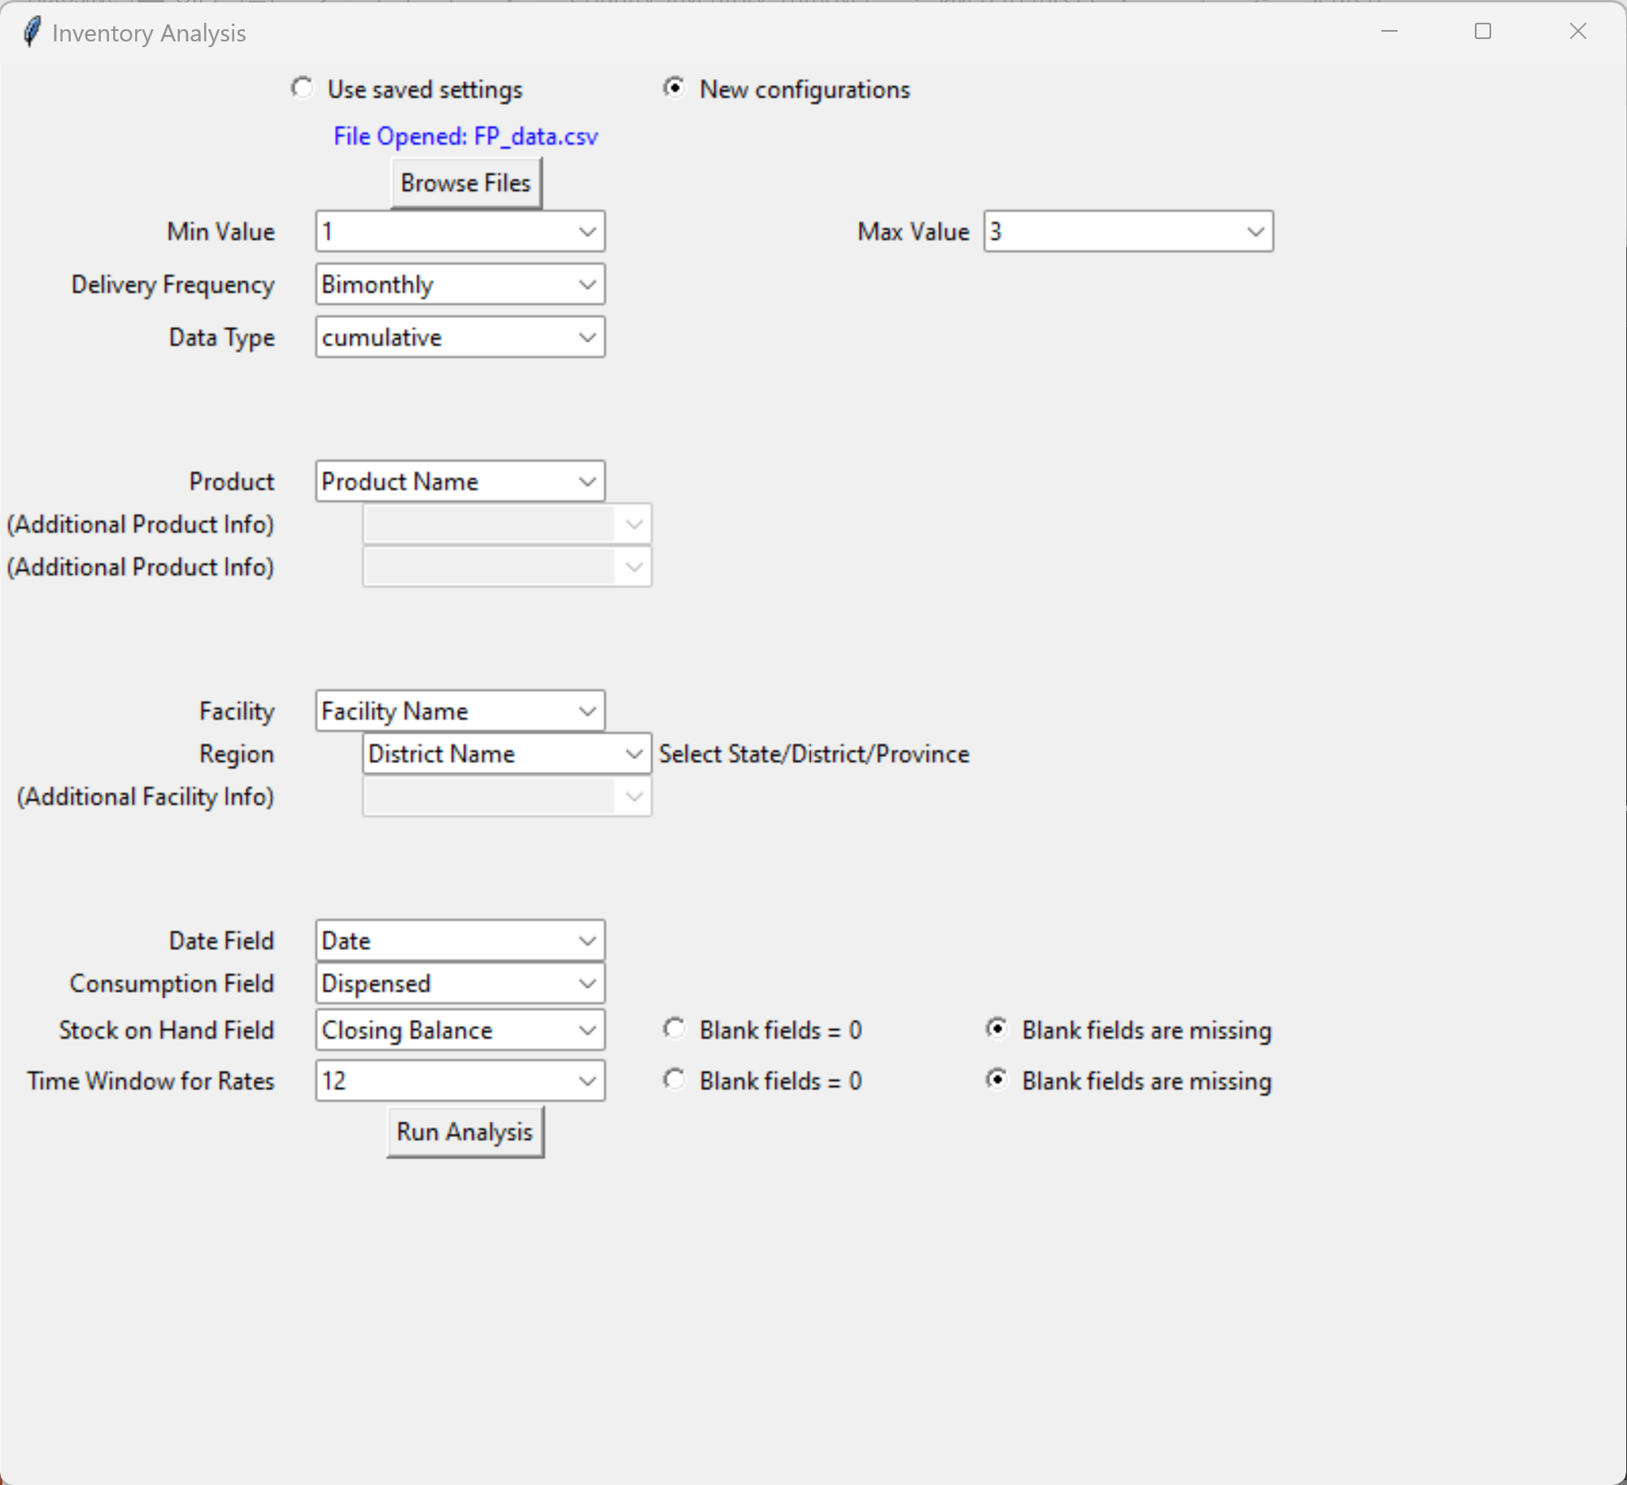

Once the tool is done running with the inputs provided by her, she opens the Excel dashboard to start analyzing her data. The FITA dashboard provides her with a clear description of each inventory turnover category (described in the section above) in the "National Summary” tab. She can see that, based on her country’s policy where max-min levels are 3 and 1 and delivery frequency is bimonthly, the tool has calculated the planned annual inventory turnover range between 4.5 and 7.5. Anything over that range is considered high or very high, and anything below that range is considered low. She can also see that of the facilities in her country’s data, most fall in the low inventory turnover range in the most recent month of data (397 facilities), 186 have planned inventory turnover, and 55 have either high or very high inventory turnover. Those in the high inventory turnover range should be watched as they may be at risk of stocking out or are potentially already stocked out.



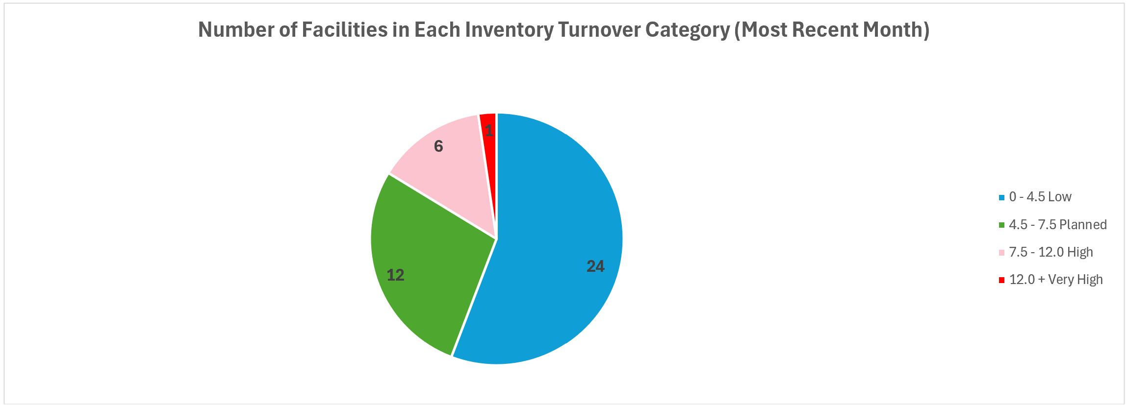

However, she is interested in issues being reported in one district and therefore uses the District/State/Province filter to narrow down the dashboard. Once the filter is applied for District X, the pie graph updates, showing her seven facilities falling in the High inventory turnover range in that district. When she scrolls down, she notices that one facility stands out at the top of the bar chart “Top 20 Facilities with % of Products in High Inventory Turnover Range.” This facility has 41% of its products in the high inventory turnover range, whereas the next highest is just 30%. She also finds this facility showing up at the top rank in the adjacent bar graph, with 26% of products in this facility already stocked out in the current month. While some of the other facilities on this list may also need help, she decides to reach out to the district manager to investigate this one first.

After getting this information from the inventory turnover analysis tool the central warehouse CEO contacts the district’s warehouse manager and asks him to use the tool and investigate these facilities, specifically Facility 9 to find out the products that are at a high risk of stocking out.

**Use Case 2: At the District Level**

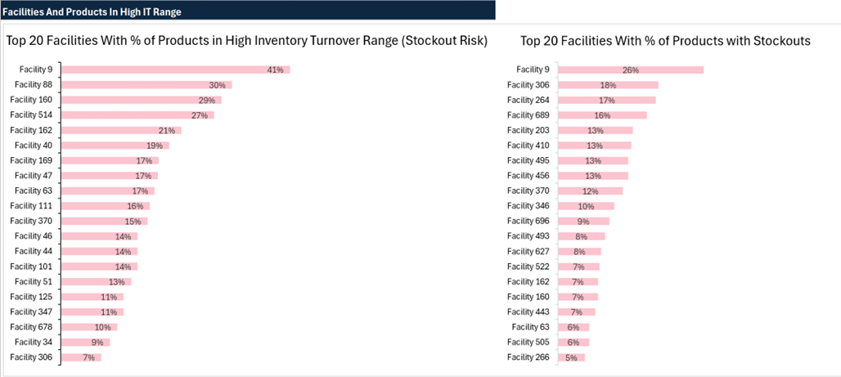

After getting a call from the CEO at the central warehouse, the district manager opens the FITA dashboard provided by the CEO to further investigate Facility 9. He navigates to the “Facility Analysis” tab in the Excel dashboard and filters for his district’s name and finds Facility 9 from the drop down. The tool now provides him with two stacked column charts showing percentage and count of products in different Inventory Turnover Categories for the facility selected. From these charts, the manager can see that there are four products in the current month which fall in the high inventory turnover category and are therefore at elevated risk of stockout.

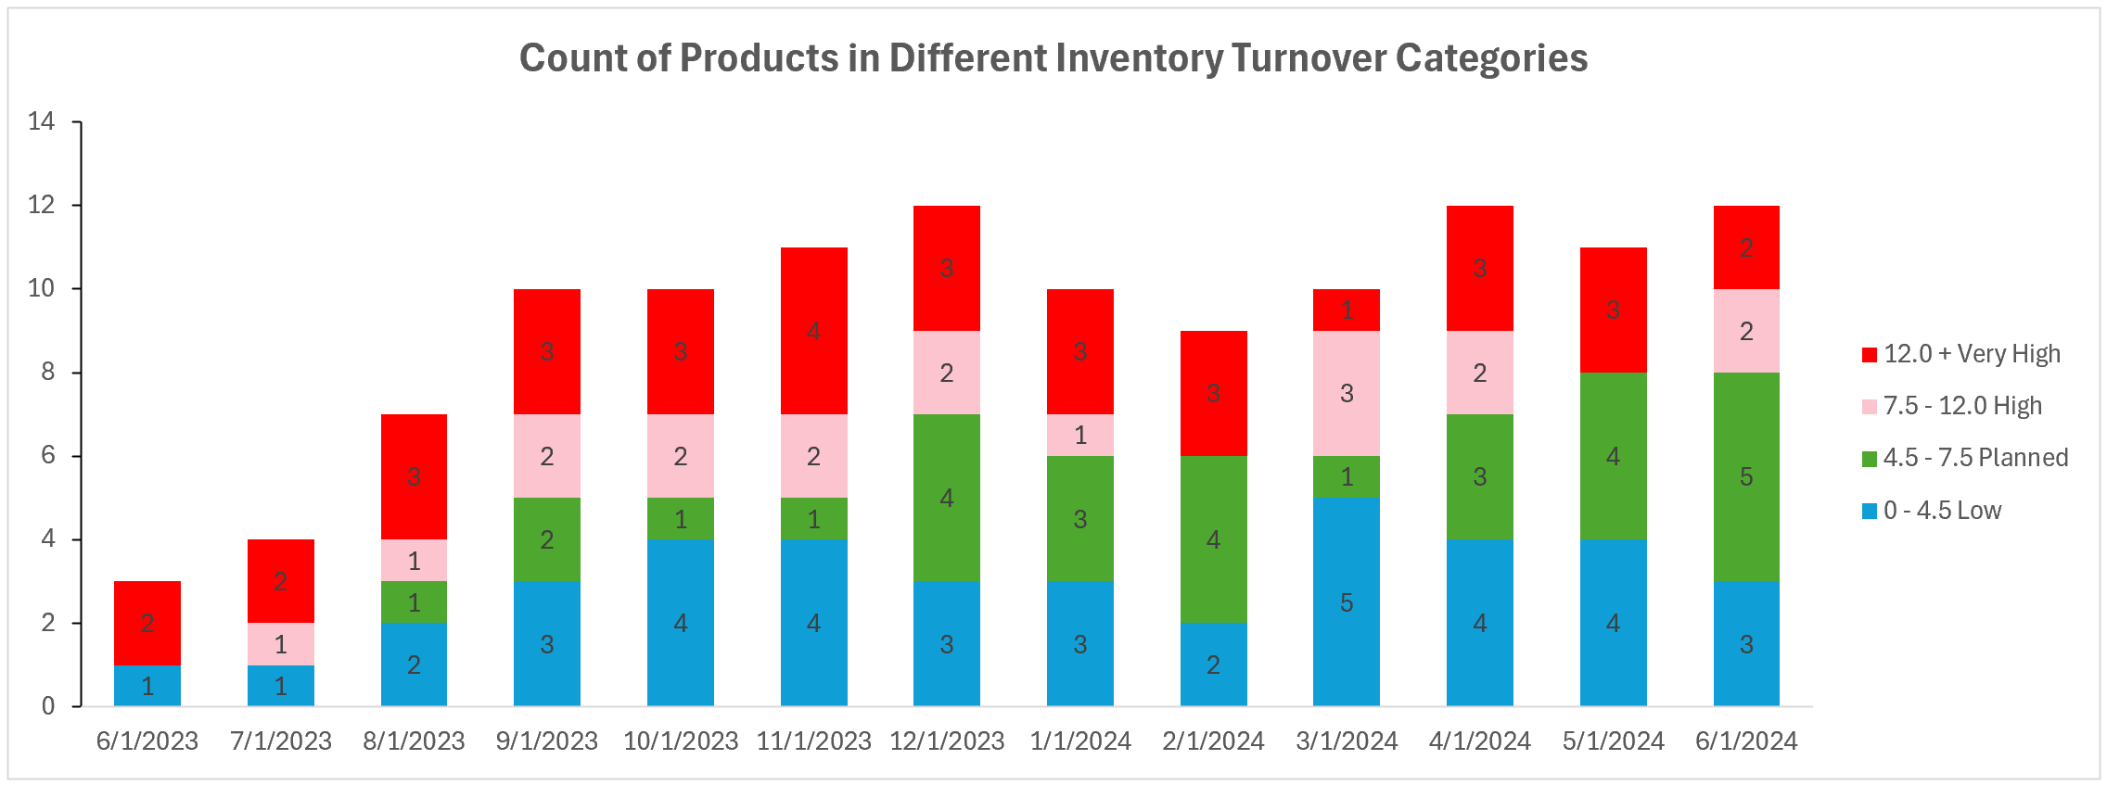

He decides to look for these products falling in the high range. He scrolls down and after selecting the current month, can see a list of all products with their inventory turnover category with the same color coding which indicate that Oxytocin and the oral contraceptive tablets Levonorgestrel only 0.03mg, brand name Microlut, are the two products in the very high inventory turnover category.[6]

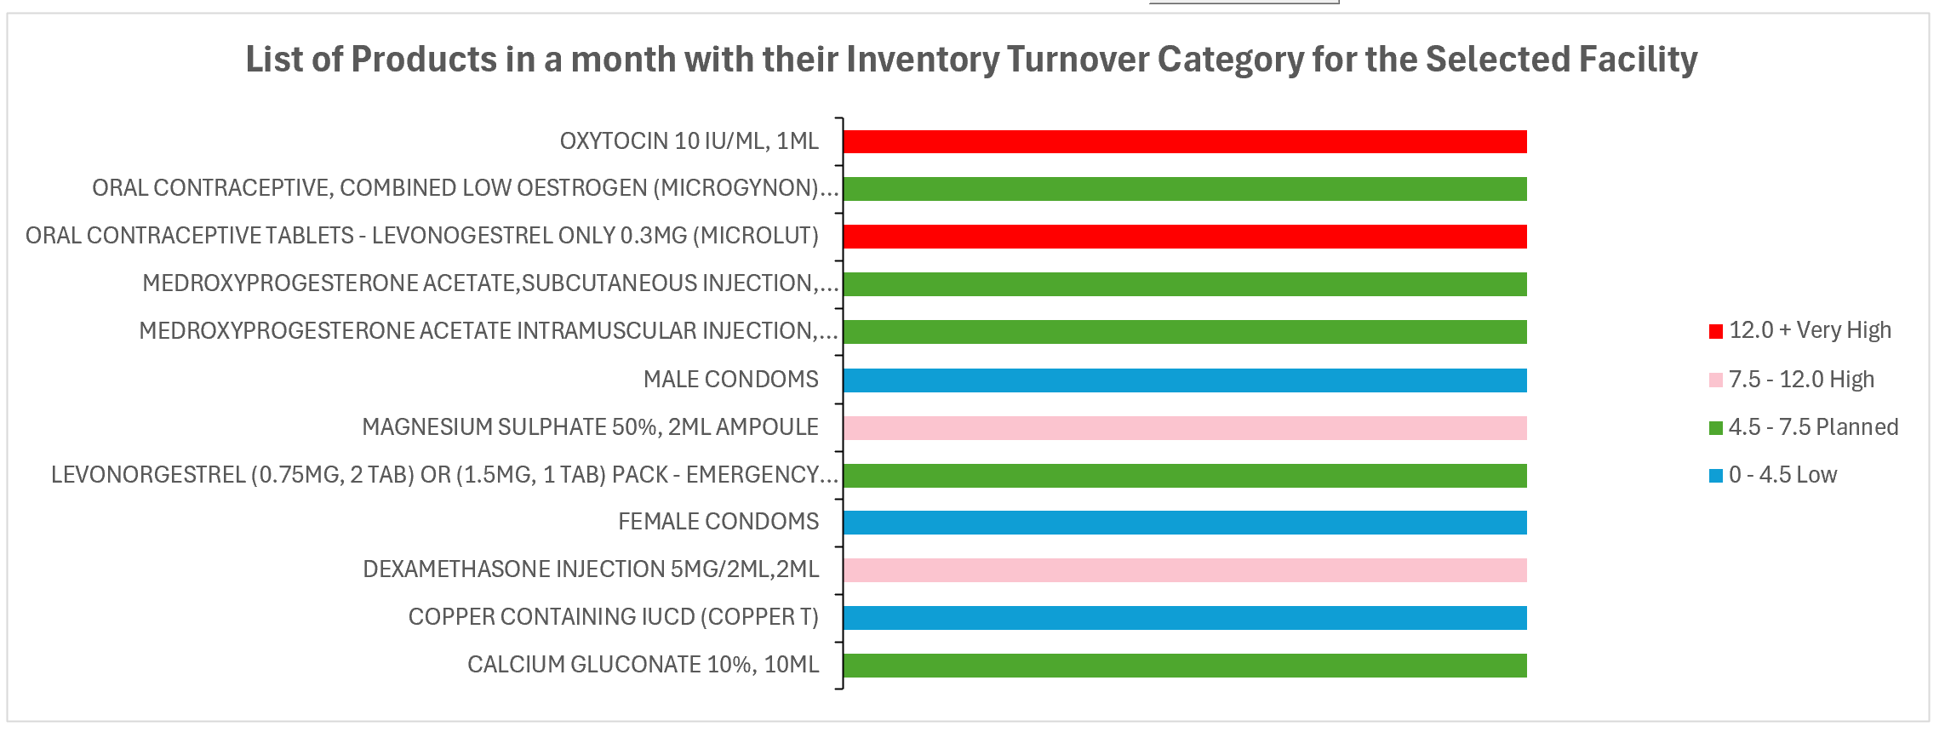

He decides to look at the Levonorgestrel only pills, which has a very high inventory turnover ratio in the chart above, and selects this product from the next dropdown in the dashboard. He now has three metric trend charts for over a year in front of him to analyze the product in Facility 9: inventory turnover, consumption, and MOS. When looking at the inventory turnover chart alongside the consumption chart, he can see that this commodity has been constantly falling in the very high inventory turnover range and has somewhat inconsistent consumption, even dropping to zero in March. This could indicate that there is a sporadic supply of this product, with frequent low stock causing rationing behaviors, reducing consumption in those months, and occasionally leading to full stock outs.

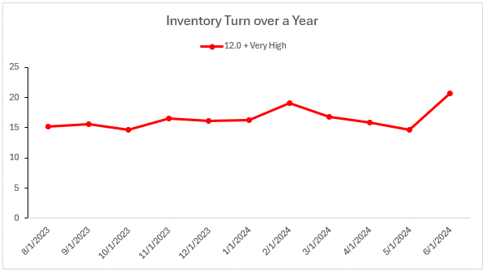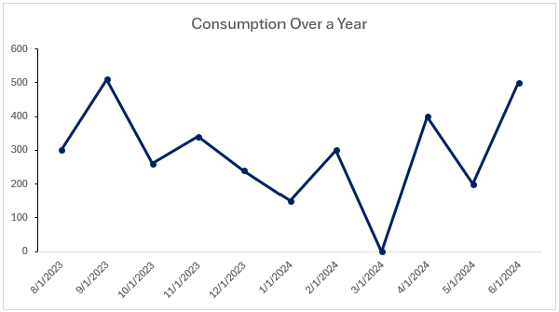

He then scrolls down to analyze the MOS chart. This chart clearly completes the picture of what is going on at this facility. The MOS is seen to be below the minimum value of 1 during multiple months, as well as MOS values at 0 for three consecutive months from November to January and then again in this most recent month. As a result, the facility is stocked out.

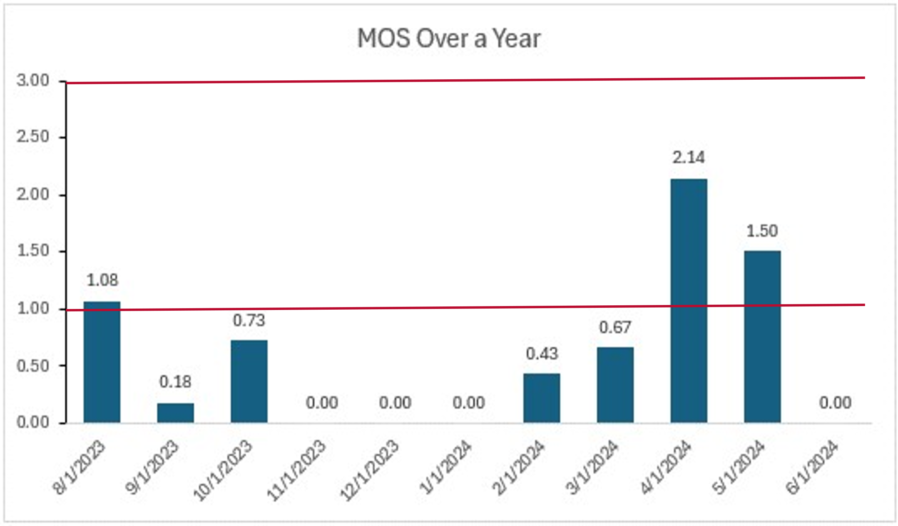

Most months below Min

The MOS Over a Year chart helps analyze the historical flow of commodities compared to the present month. Along with the consumption chart, this gives users an idea as to whether there are persistent issues that need addressing. Ideally, a consistent consumption pattern is desired in a well-maintained supply chain for non-seasonal drugs. Variability in consumption along with high or low inventory turnover range reveals poorly maintained stock levels. In that case, the MOS Over a Year chart explains the reason behind it and gives the user enough insight to be able to take the right action. Additional conversations with the facility can help determine if they need to be re-trained in proper inventory control, if they have been unable to afford the commodity based on insufficient budgets, or if they have been ordering and not receiving the commodity because the issue lies further up the supply chain, with insufficient stock at the hub or central warehouse.

The district manager now knows that this facility is not able to meet the demands of the commodity and may not be ordering enough commodity each order cycle; alternatively, perhaps the district warehouse was not stocked well and was unable to provide the commodity Facility 9 was requesting. He will need to check with the facility to find out if regular orders are being placed, if they are calculating their MOS according to the established inventory control parameters, and if the warehouse has been able to deliver the orders on-time and in-full to determine the root cause of the poor stock management. If the root cause is determined to be poor ordering by the facility, he should remind the facility of the proper ordering behavior and provide additional training if the staff requires it (e.g., perhaps a new employee took over the role without being properly trained during the transition). To fulfill the unmet growing demand of Levonorgestrel only contraceptive tablets at this facility, he may have to advise them to temporarily adjust their calculations to place greater orders than max MOS indicates until the situation is resolved, because if MOS has been based on the prior three months it will be underestimating true demand as there may have been lower consumption due to low stock levels. If the root cause is determined to be poor stock levels at the district warehouse, causing properly requested orders by this facility to not be supplied in full, he should investigate why the district warehouse was understocked — is this due to improper quantification or ordering by his staff, or due to nation-wide stockouts at the central warehouse? Once he determines the cause, he can relate this back to the CEO of the central warehouse, as well as what actions have or should be taken, particularly if the root cause lies in national shortages.

In this case, the investigation determines that the issue was with the facility’s order quantities. The CEO and district manager agree that they should provide additional guidance to the facility to revise its ordering and follow up in six months with the FITA dashboard to confirm that the intervention has been successful and stock management for Levonorgestrel only contraceptive tablets has improved. Now onto the next case!

1. Next Steps

This document included an introduction to the concept of using inventory turnover ratios for routine monitoring of the stockholding patterns of last-mile facilities and examples for how such an analysis can be done. The following steps can be taken to start using inventory turnover to monitor last-mile stock management:

1. **Advocate for including this measure in regular monitoring and evaluation of facility stock management.**   
   Share this document, or the lessons learned from it, with other key decision-makers in relevant organizations. Explain to them the benefits of using inventory turnover ratio at the facility level to identify stock keeping issues for intervention and monitoring.
2. **Determine how to best start incorporating inventory turnover into the facility monitoring workflow.**  
   There are three keyways this FITA dashboard can be used based on the status of last-mile stock monitoring in place in each county:
   1. For countries with no existing tool or dashboard for monitoring stock management KPIs using LMIS data from their facilities, they can follow the user guide to set up and start using the FITA dashboard.
   2. For countries that already have a dashboard that tracks KPIs other than inventory turnover ratio, this guide and dashboard can be provided to the system owners as a guide for a system upgrade to include inventory turnover in the dashboard.
   3. For countries that already have a dashboard that tracks KPIs including inventory turnover, this guide can be provided to users of the dashboard to help provide guidance about how to use this critically important KPI for decision-making. It may also be useful to inform a system upgrade to add a “planned” range to the dashboard for reference based on the inventory control policies in place.[7]

Inventory turnover ratio plays a key role in understanding supply chain health compared with other commonly used last-mile metrics due to its ability to provide a comprehensive, long-term perspective on stock management practices. Unlike shorter-term metrics such as MOS, which offer a snapshot based on recent data, the inventory turnover ratio delivers a more consistent and ongoing assessment of supply chain health and effectiveness for routine monitoring. This broader view is crucial for identifying systemic issues and driving improvements.

Additionally, by monitoring inventory turnover, countries can help drive improvements in this critical metric. By increasing inventory turnover, health facilities can benefit from reduced storage requirements, reduced waste and loss, and more precise supply planning. However, it is important to balance faster turnover with appropriate delivery frequencies to avoid stockouts. Ultimately, by focusing on optimizing inventory turnover and aligning resupply schedules, countries can develop a more agile, responsive, and efficient public health supply chain system, better equipped to meet evolving demands and challenges.

1. *Winning the Logistics Game*. USAID Global Health Supply Chain Program, February 2024.   
   <https://www.ghsupplychain.org/winning-logistics-game>
2. “Quantification Analytics Tool.” USAID Global Health Supply Chain Program, December 13, 2021. <https://www.ghsupplychain.org/quantificationanalyticstool>
3. Using Inventory Turnover to Assess Supply Chain Performance. USAID | DELIVER PROJECT, April 2013. https://pdf.usaid.gov/pdf_docs/PA00KDK9.pdf
4. Financial inventory turnover (based on value) is very helpful for procurement and budgeting purposes and tracking investments in inventory, but in almost all cases faster turning inventory measured in units will also be cheaper.
5. The survey was made available to all country directors within the GHSC-PSM project, and a total of seven countries responded, providing valuable feedback and insights. The participating countries were Ethiopia, Malawi, Burkina Faso, Niger, Angola, Ghana and Pakistan.
6. The country data used in this example included some typos in their product names. Levonorgestrel is misspelled and indicated as 0.3mg, rather than 0.03mg. The chart reflects the original data, but the text corrects these mistakes.
7. Planned IT range is calculated in the tool according to the following formula: (Total Consumption (over period)/Average stock on hand) ± 1.5